Prompt:
Instructions:
Selenium Java Code - package tests;

import org.openqa.selenium.By;
import org.openqa.selenium.WebDriver;
import org.openqa.selenium.WebElement;
import org.openqa.selenium.chrome.ChromeDriver;
import org.openqa.selenium.chrome.ChromeOptions;
import org.openqa.selenium.support.ui.WebDriverWait;
import org.openqa.selenium.support.ui.ExpectedConditions;

import java.time.Duration;
import java.util.ArrayList;
import java.util.Collections;
import java.util.List;

public class OffersPageTests {

public static void main(String[] args) {
// 1. Setup driver
ChromeOptions options = new ChromeOptions();
options.addArguments("--start-maximized");
WebDriver driver = new ChromeDriver(options);
WebDriverWait wait = new WebDriverWait(driver, Duration.ofSeconds(10));

try {
// 2. Navigate to Offers page
driver.get("https://rahulshettyacademy.com/seleniumPractise/#/offers");

// 3. Verify table is visible
WebElement table = wait.until(
ExpectedConditions.visibilityOfElementLocated(
By.cssSelector("table.table.table-bordered"))
);

// ---------- Test 1: Sort by Veg/fruit name ascending ----------
// Click on Veg/fruit name header
WebElement vegHeader = driver.findElement(
By.cssSelector("th[aria-label*='Veg/fruit name']"));
vegHeader.click();

// Get all values from first column
List<WebElement> nameCells = table.findElements(
By.cssSelector("tbody tr td:nth-child(1)"));

List<String> uiNames = new ArrayList<>();
for (WebElement cell : nameCells) {
uiNames.add(cell.getText().trim());
}

List<String> sortedNames = new ArrayList<>(uiNames);
Collections.sort(sortedNames);

if (!uiNames.equals(sortedNames)) {
throw new AssertionError(
"Sorting failed. Actual: " + uiNames + " | Expected: " + sortedNames);
}

// ---------- Test 2: Search filter ----------
String searchTerm = "Rice";
WebElement searchInput = driver.findElement(By.id("search-field"));
searchInput.clear();
searchInput.sendKeys(searchTerm);

// Wait for table to update
wait.until(ExpectedConditions.visibilityOfElementLocated(
By.cssSelector("table.table.table-bordered tbody tr td:nth-child(1)")));

nameCells = table.findElements(
By.cssSelector("tbody tr td:nth-child(1)"));

List<String> filteredNames = new ArrayList<>();
for (WebElement cell : nameCells) {
String text = cell.getText();
filteredNames.add(text);
if (!text.toLowerCase().contains(searchTerm.toLowerCase())) {
throw new AssertionError(
"Filter failed. Row text '" + text + "' does not contain '" + searchTerm + "'");
}
}

// ---------- Test 3: Pagination ----------
WebElement firstRowPage1 = table.findElement(
By.cssSelector("tbody tr:nth-child(1)"));
String firstRowTextPage1 = firstRowPage1.getText();

WebElement nextButton = driver.findElement(By.xpath("//a[contains(text(),'Next')]"));
wait.until(ExpectedConditions.elementToBeClickable(nextButton));
nextButton.click();

// Wait for first row on page 2
wait.until(ExpectedConditions.visibilityOfElementLocated(
By.cssSelector("table.table.table-bordered tbody tr:nth-child(1)")));
WebElement firstRowPage2 = table.findElement(
By.cssSelector("tbody tr:nth-child(1)"));
String firstRowTextPage2 = firstRowPage2.getText();

if (firstRowTextPage1.equals(firstRowTextPage2)) {
throw new AssertionError("Pagination did not change first row content.");
}

System.out.println("All validations passed successfully.");

} finally {
driver.quit();
}
}
}

[CRITICAL] Analyze the current selenium java code
[CRITICAL] Step back and analyze line by line and understand the code.
[CRITICAL] [MANDATORY] Convert the Selenium code into Playwright typescript code
STRICTLY Generate a production ready test code which should get passed without any compilation error in any compiler. I will be testing the generated code in https://try.playwright.tech/?l=playwright-test

Context: I need to convert selenium java code to Playwright typescript code

Persona: Act as a playwright typescript automation expert

Output: Playwright typescript code

Tone: Professional

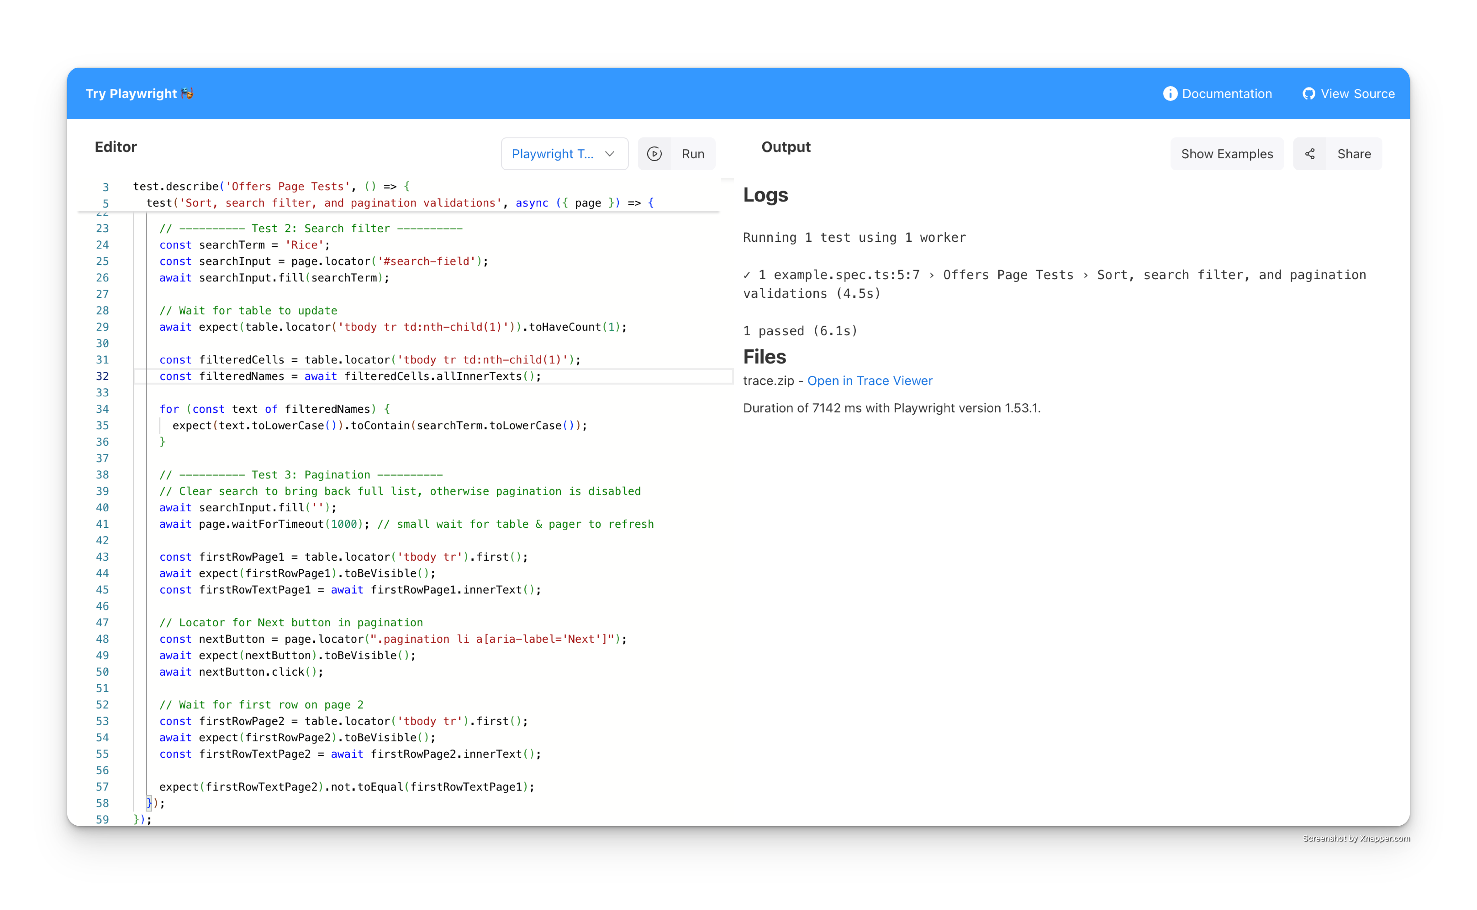

import { test, expect } from '@playwright/test';

test.describe('Offers Page Tests', () => {

test('Sort, search filter, and pagination validations', async ({ page }) => {
// 1. Navigate to Offers page
await page.goto('https://rahulshettyacademy.com/seleniumPractise/#/offers'); // [web:21]

// 2. Verify table is visible
const table = page.locator('table.table.table-bordered');
await expect(table).toBeVisible();

// ---------- Test 1: Sort by Veg/fruit name ascending ----------
const vegHeader = page.locator("th[aria-label*='Veg/fruit name']");
await vegHeader.click();

const nameCells = table.locator('tbody tr td:nth-child(1)');
const uiNames = (await nameCells.allInnerTexts()).map(t => t.trim());

const sortedNames = [...uiNames].sort((a, b) => a.localeCompare(b));
expect(uiNames).toEqual(sortedNames);

// ---------- Test 2: Search filter ----------
const searchTerm = 'Rice';
const searchInput = page.locator('#search-field');
await searchInput.fill(searchTerm);

// Wait for table to update
await expect(table.locator('tbody tr td:nth-child(1)')).toHaveCount(1);

const filteredCells = table.locator('tbody tr td:nth-child(1)');
const filteredNames = await filteredCells.allInnerTexts();

for (const text of filteredNames) {
expect(text.toLowerCase()).toContain(searchTerm.toLowerCase());
}

// ---------- Test 3: Pagination ----------
// Clear search to bring back full list, otherwise pagination is disabled
await searchInput.fill('');
await page.waitForTimeout(1000); // small wait for table & pager to refresh

const firstRowPage1 = table.locator('tbody tr').first();
await expect(firstRowPage1).toBeVisible();
const firstRowTextPage1 = await firstRowPage1.innerText();

// Locator for Next button in pagination
const nextButton = page.locator(".pagination li a[aria-label='Next']");
await expect(nextButton).toBeVisible();
await nextButton.click();

// Wait for first row on page 2
const firstRowPage2 = table.locator('tbody tr').first();
await expect(firstRowPage2).toBeVisible();
const firstRowTextPage2 = await firstRowPage2.innerText();

expect(firstRowTextPage2).not.toEqual(firstRowTextPage1);
});
});

